Boresighting and IT.doc
June 17, 2015

DRAFT
MEMORANDUM

Subject: Boresighting, Weapons, Information Technology, Doctrine, and Ontologies

- Purpose. To first explain the boresighting of weapons and then use that procedure in explaining that ontologies used in information technology (IT) should be aligned with the doctrinal manuals in which warfighters document their vocabulary and procedures.

- Basic Point. Understanding boresighting facilitates understanding the role of doctrinal manuals in providing warfighters with IT systems for command and control (C2) and other warfighting activities. Warfighters boresight weapons because hitting the target when a weapon is fired requires the weapon’s sight (and thus warfighter using the sight to control the weapon) be aligned with the barrel. Without boresighting, weapons can function properly (i.e., fire) but miss the target. Boresighting is sometimes done by aiming the barrel and the sight at a boresighting target. The target provides a single reference for (a) the warfighter, (b) the sight through which the warfighter is looking, and (c) the barrel. The same effect is achieved when the doctrinal manual with which warfighters standardize terminology and processes are used as the basis for IT development, particularly ontologies.

- Overview. This document explains:

  - The need to align IT with warfighters by using doctrinal manuals as IT “boresighting targets.”

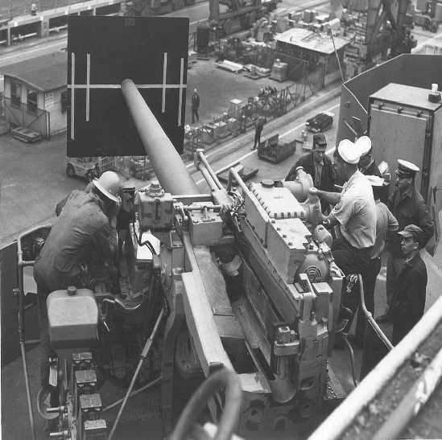
  - The value of removing ambiguous or other imprecise statements from doctrinal manuals. Warfighters usually understand what is intended in an ambiguous or imprecise statement in a doctrinal manual. However, such statements can lead IT developers to develop an ontology or other software element that will, like a gun that has not been boresighted, cause the IT to “missing the target.”

- Discussion

  - To boresight a weapon is to adjust the weapon so that the weapon’s barrel is pointed at whatever the person using the weapon sees through the weapon’s sight. Without boresighting, in the activity in the picture to the right, a warfighter may think he is aiming the barrel at what he is looking at through the sight but actually be pointing the barrel at something else. Note the boresighting target at the end of barrel. The target provides a single reference for the barrel, sights, and warfighters.
Sailors boresighting a gun

  - Boresighting is necessary because while a tool should be as easy as possible to use, tools often have physical realities that when ignored reduce or eliminate the tool’s effectiveness. The practice of boresighting illustrates that warfighters can understand such realities and compensate for them with activities such as boresighting.

  - IT has realities similar to those that require weapons to be boresighted. Just as a gun shoots a round at whatever object its barrel is pointed, so an IT system generates data using whatever terminology it is set up to use. For example, warfighters through their doctrinal manual have specified that a task is an “action or activity assigned to an individual or organization” while a mission “entails the task, together with the purpose, that clearly indications the action to be taken and the reason therefore.” A function is the “broad, general, and enduring role for which an organization is designed, equipped, and trained.” However, an IT system designed with little attention to doctrine may mix-up the terms and definitions. For example it might build into its terminology a view according to which: (1) a mission of the unit is what the unit is designed, equipped, and trained (i.e., function in doctrine), (2) a task is what is to be accomplished with reason therefore (i.e., mission in doctrine), and (3) a function is a specific action to be taken by the unit in the course of accomplishing its mission (i.e., function in task). DO YOU HAVE A CONCRETE EXAMPLE OF SUCH MISMATCH? If an IT system based on this second set of definitions is queried by a warfighter about the mission of a unit, the IT will provide a description of what is defined in doctrine as the unit’s function. A warfighter who has not boresighted his weapon can figure out in battle through trial and error that he needs to fire slightly above whatever he wants to hit. Similarly, a warfighter using an IT system that has not been “boresighted” with doctrine can figure out to use the term “mission” when he is querying the IT system for a unit’s function and the term “function” when he is querying for the tasks assigned to a unit. Just as a weapon is boresighted before a battle with a boresighting target, so too should an IT system be boresighted by ensuring consistency with doctrinal manuals as it is being built. Such boresighting should be tested in realistic training scenarios before the IT system is deployed in battle.

  - Unfortunately doctrinal manuals themselves contain ambiguous and otherwise imprecise statements. Warfighters are human beings, and so able to compensate for these defects, in part by drawing on normal human facilities for understanding natural language, in part because of their education, training, and operational experience. Thus they are able to grasp what was intended by the manual’s author. Those IT developers who lack warfighters’ education, training, and experience, where they look at doctrine publications at all in support of their work, often ← do you have evidence for this? see these ambiguities and imprecise statements for what they are (i.e., ambiguous and imprecise) and then either set the doctrinal manuals aside as basis for developing IT or interpolate a meaning that is different from the author’s intended meaning. When the IT developer misunderstands the doctrinal manual, she or he often provides warfighters with IT that is not “boresighted” with warfighter. By removing ambiguity and imprecision, authors of doctrinal manuals improve the manuals’ usefulness as “boresighting targets” with which IT developers can better align their IT systems with warfighters’ needs and understanding of warfare.

- Conclusion

  - Developers of IT facilitate the “boresighting” (i.e., aligning) of their products with warfighters’ needs by using doctrinal manuals as “boresighting targets.”

  - Just as warfighters understand the need to use boresighting targets when boresighting their weapons, so too should they understand the need to contribute to better IT by improving their doctrinal manuals through the removal of ambiguities and imprecise statements as the manuals are revised.

  - IT developers who are seeking to use doctrinal manuals in the development of IT should be able assist the doctrinal manuals’ authors by identifying ambiguous and imprecise terms and statements.

The authoritative source for all these terms and definitions is Joint Publication (JP) 1, Doctrine for the Armed Forces of the United States. See paragraph 7 in Chapter 1, “Theory and Foundations,” of JP-1.

